Things I’m good at

- I have a fabulous smile, and I’m good at using it to make friends and for ‘flirting’
- Swimming – I’m a water baby with no fear
- Eating and drinking – bring it on!!
- Playing – at the moment, it’s going (on my bottom) on the trampoline (with someone)

Tricky Things
- I don’t like touching sticky stuff.
- People keep wanting to give me symbols to look at, but I can’t make much sense of them – yet. Best to stick to real objects and clear photos of things I know well. (I like being in charge of taking photos)
- People are not sure how well I see (that may be why I’m better at listening and choosing from spoken choices).

Things about Me
- I am VERY NOSY and I listen to everything – you’ve been warned!
- I am generally very cheer-
ful, so there’s usually a
good reason if I’m upset –
up to you to find out what
is wrong, I can sometimes answer Yes/No questions.
- I am not very good at waiting – I just don’t understand ‘later’. If you tell me something is going to happen, I will expect it NOW!
How I Communicate
- I use my eyes and my face (& body) to show how I’m feeling.
- I can use my eyes to ‘point’ to things, or people. Ask me ‘Can you show me with your eyes?’
- For ‘NO’ (or ‘I don’t like that’) my face crumples up and I hang my head down. (Or I get very cross…)
- For ‘YES’ (or ‘I like that’), I throw my head & eyes up and flash you a winning smile

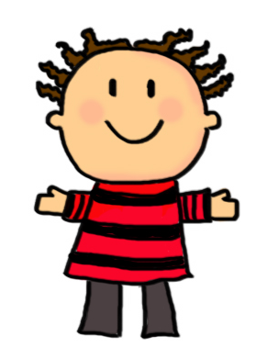
My favourite things
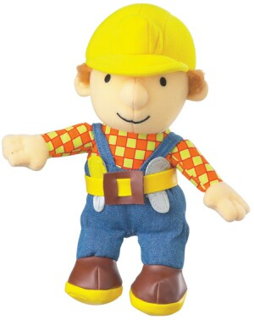
- Food! I love it all (except bananas).
- I like videos (not TV), Bob the Builder especially (the song), & In the Night Garden
- I love all music – especially singing Nursery rhymes I know and anything fast, loud and bouncy.
- My favourite game is ‘rough and tumble’ & tickling with my Dad

Things that help me
- Get down to look me in the eye
- Say my name to make get me to look and listen
- Speak slowly
- Don’t say too much – one ‘chunk’ of information at a time is just enough for me
- Then give me quiet time to take it in and think
- Show me things or point to things to help show what you mean. Some simple gestures and signs can help too. 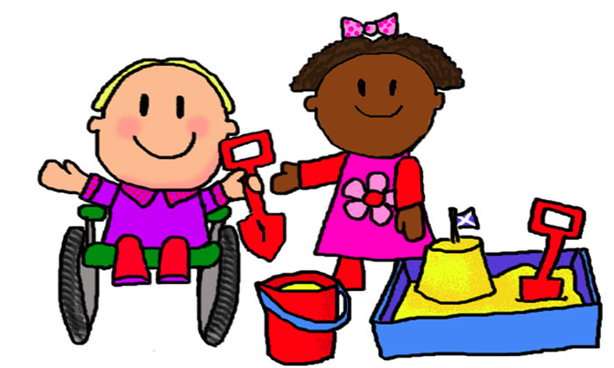



Bobby has cerebral palsy, causing complex additional learning and communication support needs. He can hear normally and he understands a fair amount of what other people say, if they keep their language very simple and direct. He finds it difficult to concentrate. Bobby has expressive language in his head but he can’t get it out because of his neurological & physical difficulties with coordinating breathing and moving his mouth to make speech sounds. He can use non-verbal body/face/eye signals to communicate, at a pre-intentional but pro-active level. He can sometimes make a simple choice (from 2 or 3) if real objects or a ‘list’ presented verbally (but not pictures).
Bobby is having his functional vision assessed and is also working towards using pictures & symbols for communication.
He can use his right hand to hit a light touch switch and enjoys a variety of simple ‘cause and effect’ computer software, but he can’t scan yet.
Hi, I’m
Bobby Brown
- I’m 5 years old
- I live in Sauchie
- I have one big brother Jake
- I have two sisters, Eilidh and Soo
- I have a black cat called Sox
- I go to Sauchie Primary school
- I’m in P1

This leaflet

Keep Up to Date

It’s really important that this leaflet is kept up to date with relevant information to help new people get to know Bobby and how best to talk with him. You may decide that there’s not enough room for important information and that Bobby needs a bigger Passport booklet. Speak to his Speech and Language Therapist or teacher about this

If you want to find out more about Passports, look up www.communicationpassports. org.uk or try 0131 651 6235/6
(CALL Centre, Sally Millar)
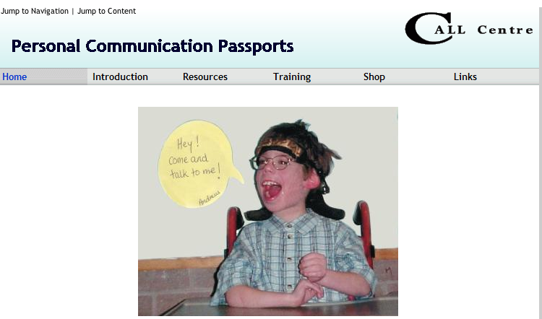
About communication
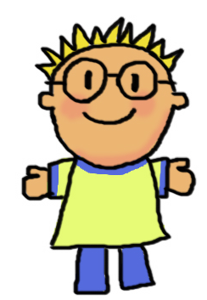
This leaflet was made by Bobby and his Mum, with help from Sally Millar, CALL Scotland, April 2012

